
A
LAB RECORD

On
Modern Operating System Design

Master
of
Computer
Application
-
1
^{st}
Sem
RUNGTA
INTERNATIONAL
SKILLS
UNIVERSITY
SESSION:
202
5
-
2
6
Submitted
By:-
Submitted to:-
Student
Name-
Piyush
Kumar Karsh
Ref
No.
RU-25-10967
Mr. Lakshman Sahu Sir

RUNGTA
INTERNATIONAL
SKILLS
UNIVERSITY
,
CG
SCHOOL
OF
INFORMATION
TECHNOLOGY

INDEX

 | S No | Name Of Practical | Submission Date | Remarks
 | 1. | Write a Python program to display Operating System name, version, and architecture using the platform library. | 22/09/2025
 | 2. | Write a Python program to show Disk Partitions and Usage. | 22/09/2025
 | 3. | Write a Python program to display total memory, used memory, and available memory using the psutil library. | 29/09/2025
 | 4. | Write a Python program to list the top 5 running processes (process name + PID). | 29/10/2025
 | 5. | Write a Python program to display Monitor Network Statistics (Bytes Sent/Received). | 13/10/2025
 | 6. | Implement First Come First Serve (FCFS) CPU scheduling in Python. | 13/10/2025
 | 7. | Implement Round Robin Scheduling with different time quantum. | 10/11/2025
 | 8. | Implement Priority Scheduling and show waiting time vs turn around time. | 10/11/2025

EXPERIMENT.1
AIM - Write a Python program to display Operating System name, version, and architecture using the platform library.

SOURCE CODE –
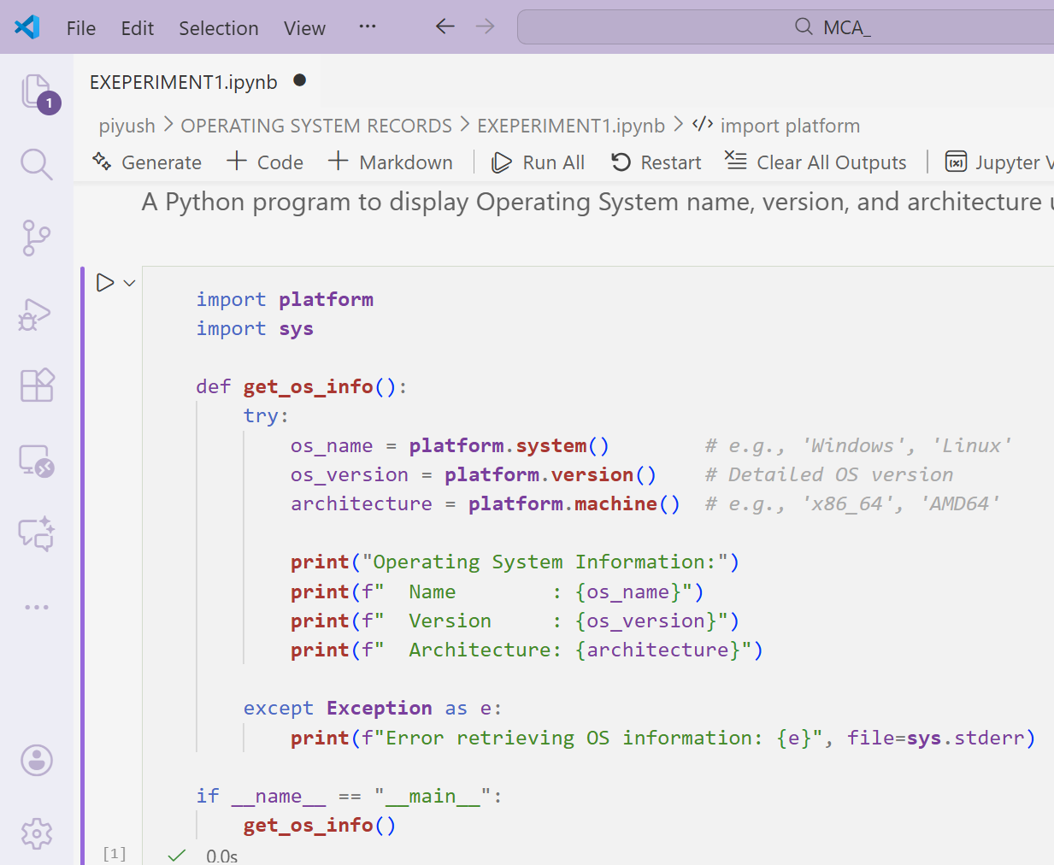

OUTPUT -


EXPERIMENT.2
AIM - Write a Python program to show Disk Partitions and Usage.

SOURCE CODE -
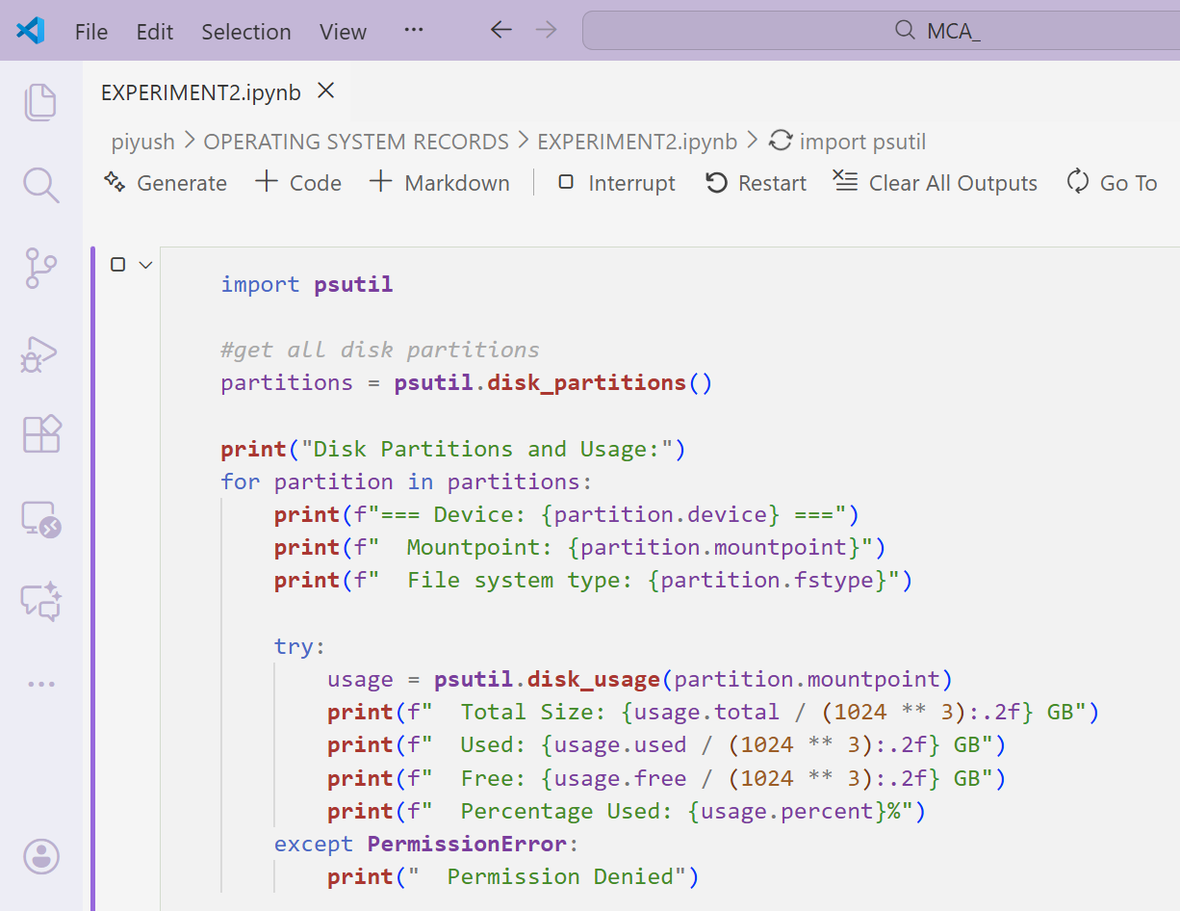

OUTPUT -
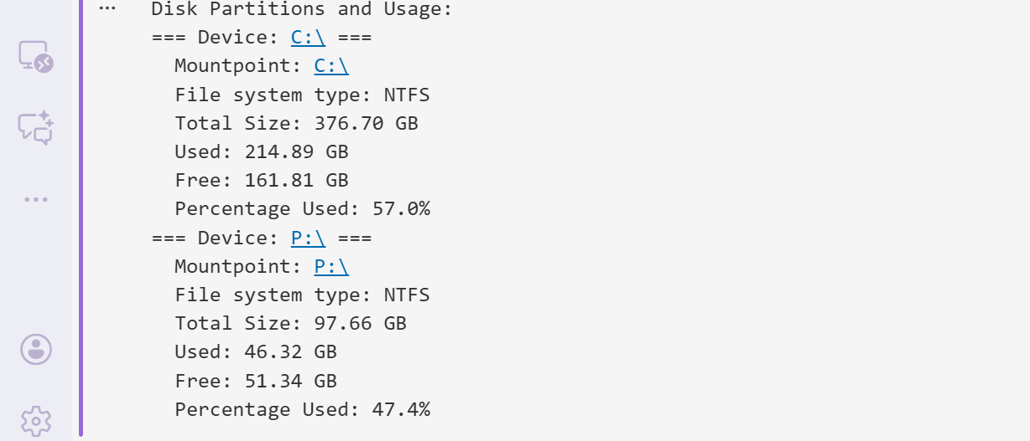

EXPERIMENT.3
AIM - Write a Python program to display total memory, used memory, and available memory using the psutil library.

SOURCE CODE -
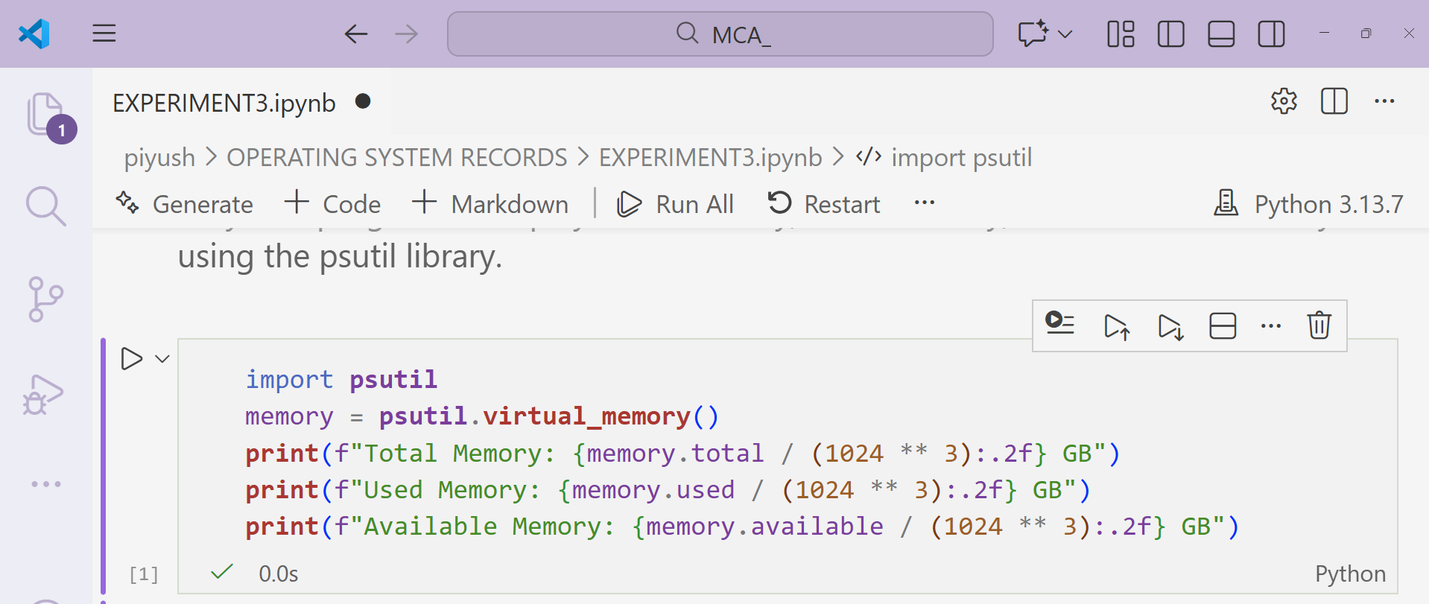

OUTPUT -
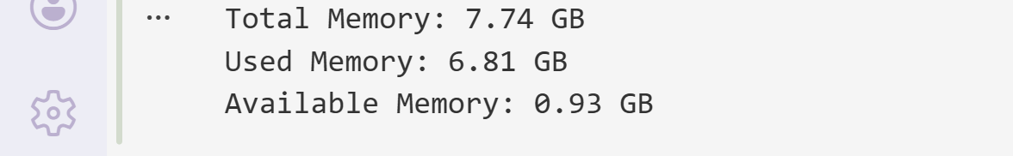

EXPERIMENT.4
AIM - Write a Python program to list the top 5 running processes (process name + PID).

SOURCE CODE -
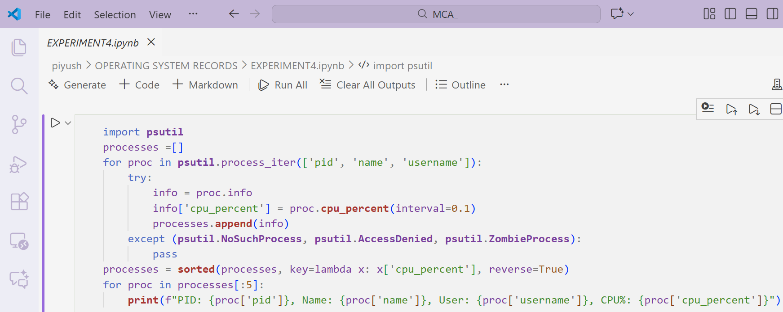

OUTPUT -
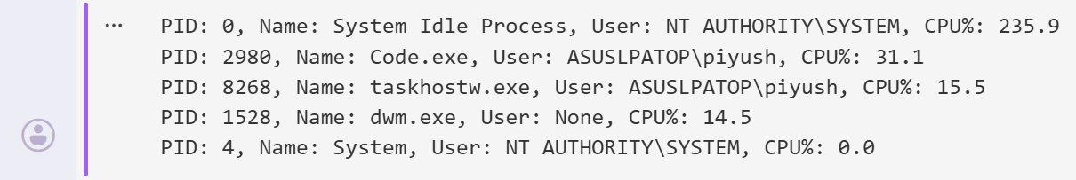

.

EXPERIMENT.5
AIM - Write a Python program to display Monitor Network Statistics (Bytes Sent/Received)

SOURCE CODE -
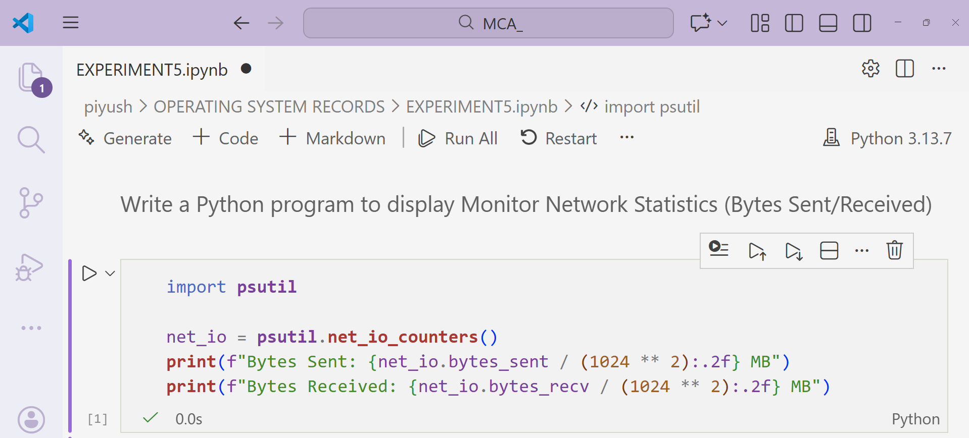

OUTPUT –
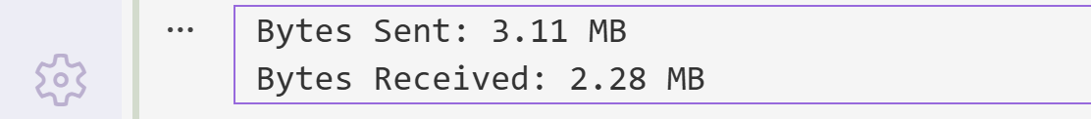

EXPERIMENT.6
AIM - Implement First Come First Serve (FCFS) CPU scheduling in Python.

SOURCE CODE -
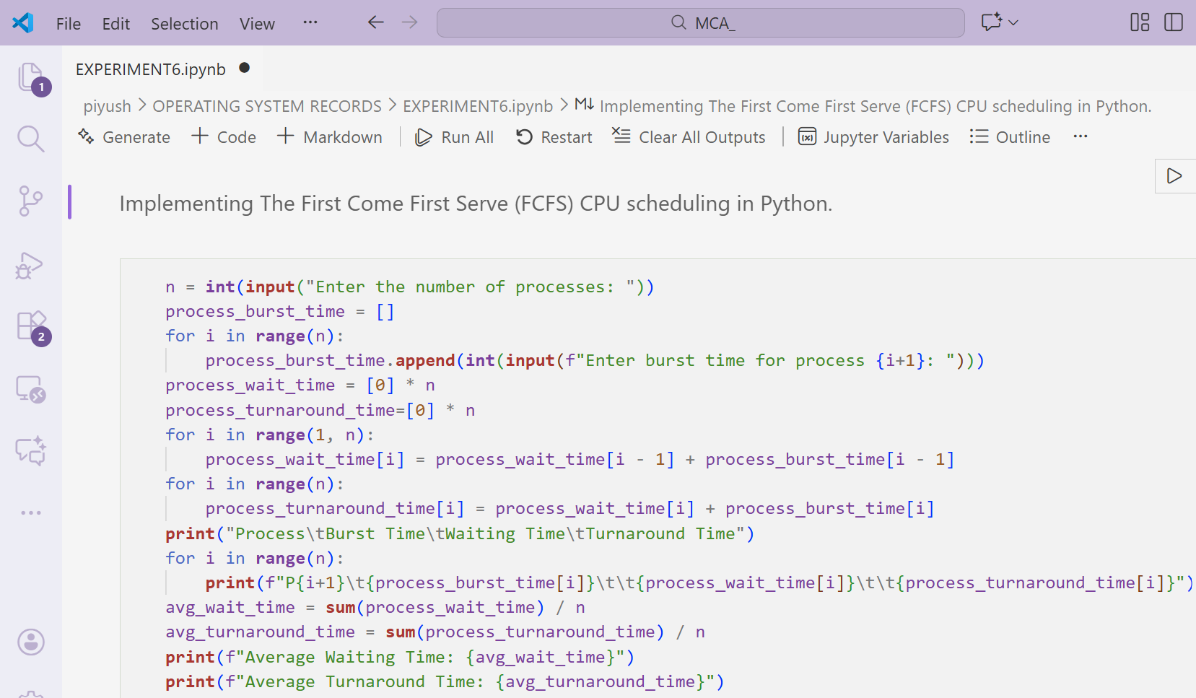

OUTPUT -
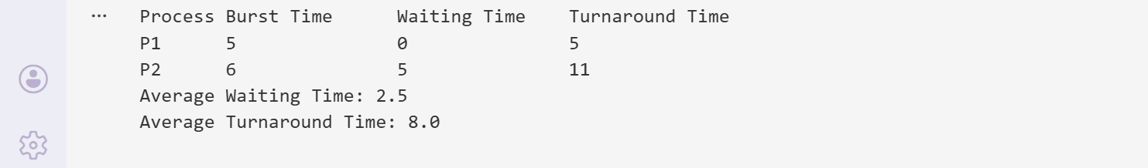

EXPERIMENT.7
AIM - Implement Round Robin Scheduling with different time quantum.

SOURCE CODE -
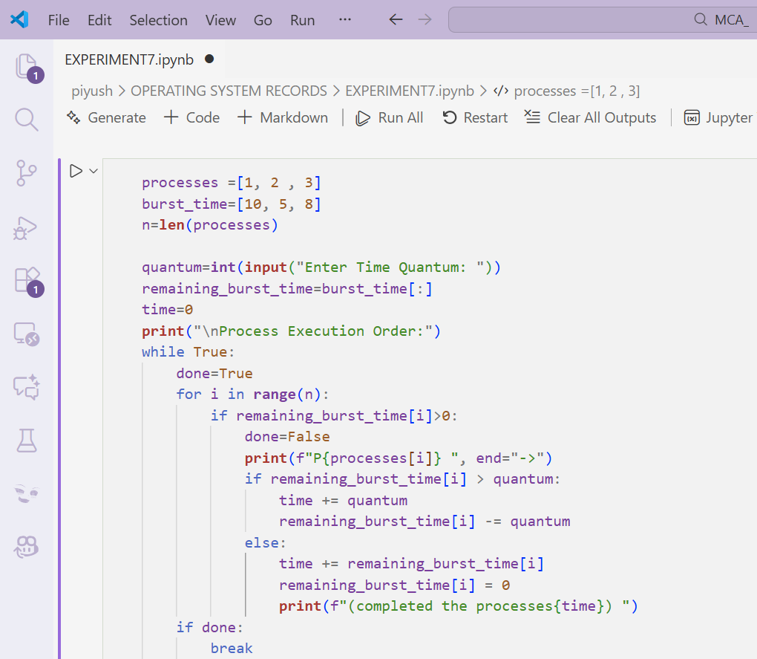

OUTPUT -
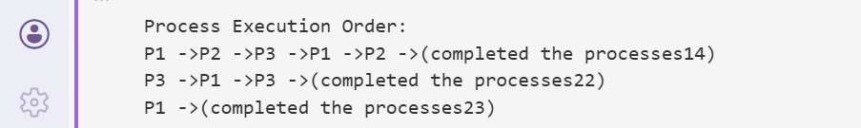

EXPERIMENT.8
AIM - Implement Priority Scheduling and show waiting time vs turn Around time.

SOURCE CODE -

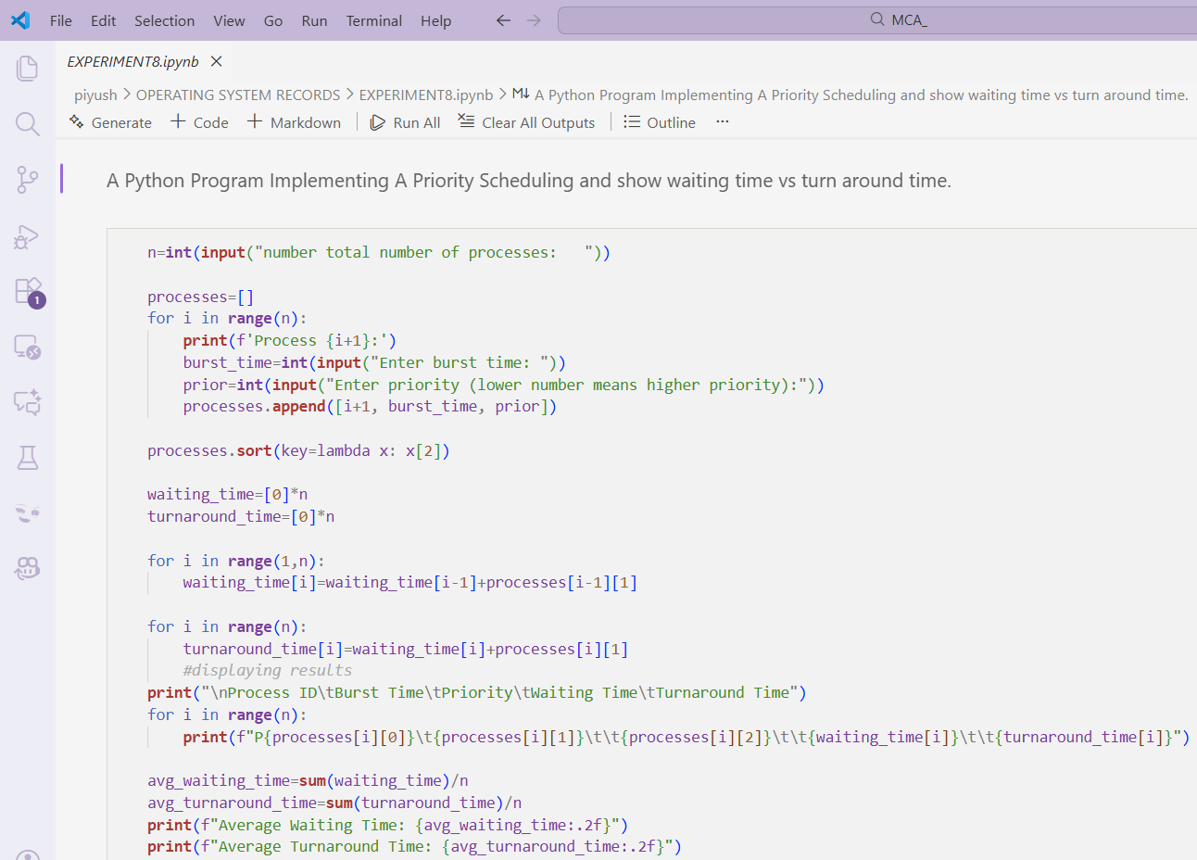

OUTPUT –
